# Lab: Spring Boot and Spring Data

# MobiLeLeLe web application

MobiLeLeLe is an application in which you register cars, with several properties.

You will have to create a simple application which has several pages and some object entities.

## Data

This is the data layer of the application. There are some data object for you to implement.

### Brand

Create a Brand class, which holds the following properties:

* id – a **uuid or number**.
* name – a **name of brand**.
* **created** – a **date and time**.
* modified – a **date and time**.

### Model

Create a Model class, which holds the following properties:

* id – **uuid or number**.
* name – a **model name**.
* category – an enumeration (Car, Buss, Truck, Motorcycle)
* imageUrl – the **url of image** with size between 8 and 512 characters.
* startYear – a **number**.
* endYear – a **number**.
* **created** – a **date and time**.
* modified – a **date and time**.
* brand – a **model** **brand**.

### Offer

Create a Model class, which holds the following properties:

* id – **uuid or number**.
* description – some **text**.
* engine – **enumerated** value (GASOLINE, DIESEL, ELECTRIC, HYBRID).
* imageUrl – the **url of image**.
* mileage – a **number**.
* price – the **price of the offer**.
* transmission – **enumerated** value (MANUAL, AUTOMATIC).
* year – the **year** of offered car.
* **created** – a **date and time**.
* modified – a **date and time**.
* model – the **model of a car**.
* seller – a **user that sells the car.**

### User

Create a User class, which holds the following properties:

* id – **uuid or number**.
* **username** – username of the **user**.
* **firstName** – first name of the **user**.
* **lastName** – last name of the **user**.
* isActive – **true OR false**.
* role – **user's role (User or Admin)**.
* imageUrl – a url of user's picture.
* **created** – a **date and time**.
* modified – a **date and time**.

### UserRole

Create a UserRole class, which holds the following properties:

* id – **uuid or number**.
* **role** – **enumerated** value.

This is an example of ER Diagram

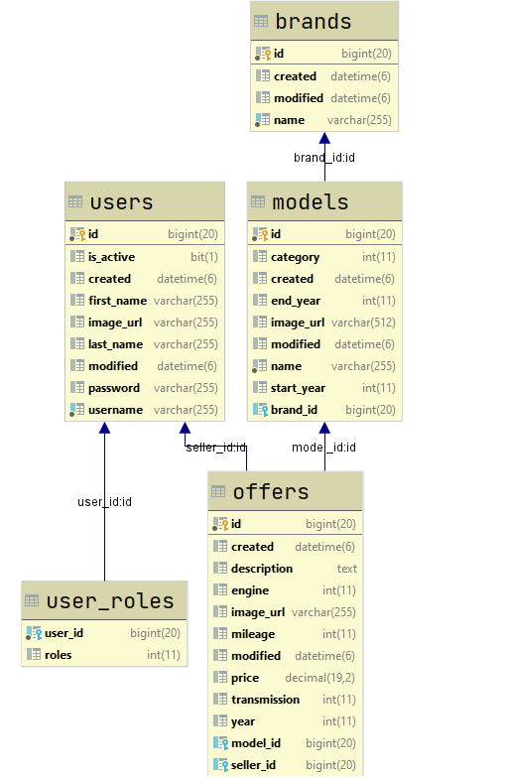

## Populate DB

* You will be given some cars data, that you must populate the database with. Create Data Initializer class, that reads information about cars from file and store it in the database when application starts for the first time.

Hint:

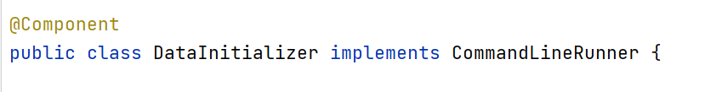

## Prepare All needed layers

* Repositories
  + If you want, you can implement some common methods
* Services and their implementations
  + If you want, you can implement some common methods in implementations
* ServiceModels, that contains the same fields as the entity

In the next Lab, we continue working on this application